

Assignment

**Course: TIS2151: Web Application Development**

**Group Members:**

|  |  |  |  |
| --- | --- | --- | --- |
| NO | STUDENT ID | NAME | WORK DISTRIBUTION |
| 1 | 1151103687 | Samuel Wong Ing Shiing | - Main Programmer  - Problem Statement  - Solution: Implementation |
| 2 | 1151102347 | Wayile Jialade | - Main Designer  - Abstract  - Solution: Analysis |
| 3 | 1161304245 | Muhammad Afif Muqri bin Hambali | - UI Designer  - Tester and Screenshots  - Solution: Design |
| 4 | 1161300859 | Muhd Safwan Zarif bin Ya’cob | - Programmer and Tester  - Objectives  - Conclusion |

**Abstract**

With the increasing number of large-scale activities or events of our country, the traditional event management model based on manual system has been greatly impacted, with the manual event management system, the resources of the event organizers(e.g. Sponsor Fund, Equipment, Human resources, etc) could not be reasonably utilized, as the event organizers could not realize the situation of his events in real time. With the development of science and technology, the arrangement, planning and security issue of large-scale events have been paid more and more attention by the organizers. Therefore, it is necessary to develop a set of computerized event management system or software for large-scale event organizers.  
 After years of business collaboration with universities, colleges, government agencies, sports events, exhibitions and other activities, our group had gathered enough experience in extracting the corresponding business model by analyzing the relevant business processes combining with efficient and latest management concepts, therefore we have developed a set of specialized event management software for large-scale events. The mission of our company is to provide our service as best as possible from the perspective point of view of the event organizers.

**Problem Statement**

With the ever increasing flow of data in for companies in event management, a fluid, systematic, and useful system is always in demand to help them manage their customers and followers better. Outdated system that uses hard copy records and have a worker transfer them later into a database can be slow and taxing. Data that needs to be stored is increasing every day and need to be cleaned and verified. A system that has helpful functions such as online event registration and online event attendance recording can certainly help these problems.

**Problem Objectives**

We are looking to build a web-based application that can:

1. Help event administrators to create and view their event using the web.
2. Help administrators and participants to view, search, and join these events.
3. Be used by administrators to track the attendance of participants for their events.
4. Store all relevant data into the database for future references of the administrators.

**Functions Designer**

1. **Samuel Wong Ing Shiing**
   * Create Event
   * View Event
2. **Waylie Jialade**
   * Search Event
   * Join Event
3. **Muhammad Afif Muqri bin Hambali**
   * Update Attendance
   * UI: Event Lists, Main Page
4. **Muhd Safwan Zarif bin Ya’cob**
   * View Attendance
   * UI: Find Event, Attendance List

**Solution**

i) Analysis

1. Use-case Diagram

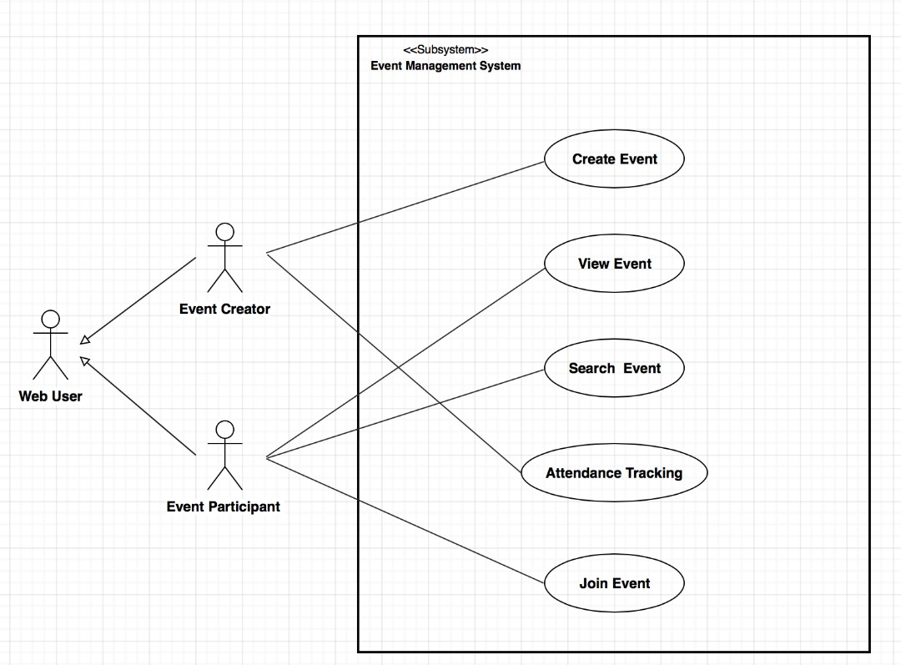

First of all, there are two type of users for this event management system, the event creator and the event Participant, when you are the event creator, you will be directed to the web pages that associated with something like create events and attendance tracking or updating the current attendance, when you are the event participant, you will be able to search events, view events and join events.

b)Requirements:

The following are the requirements for our web-based application:

1. The administrators and participants can access the event management system through the web
2. The admins can create an event and it can be viewed by the admins and the participants.
3. The admins can record and keep track of the attendance of participants for their events
4. The users can search for registered events.
5. The participants can join the events that have been created.
6. All data can be stored into the database and be viewed by administrators at any time.

ii) Design

1. Web Flow Diagram

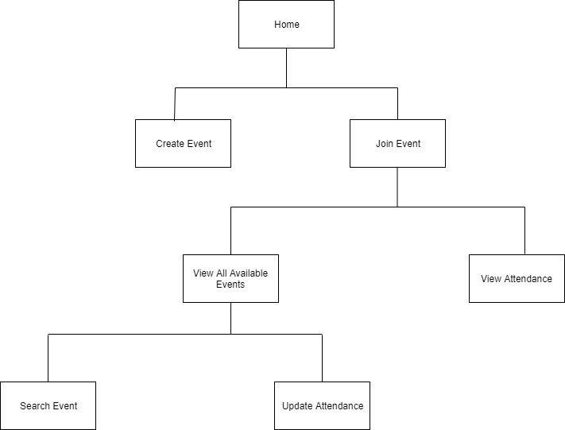

iii) Implementation

1. Limitation
   1. The system is written in PHP.
   2. This system will store data into the MySQL database.
   3. The current prototype of the system does not have a login function to limit the usage permission of users.
2. Screenshots

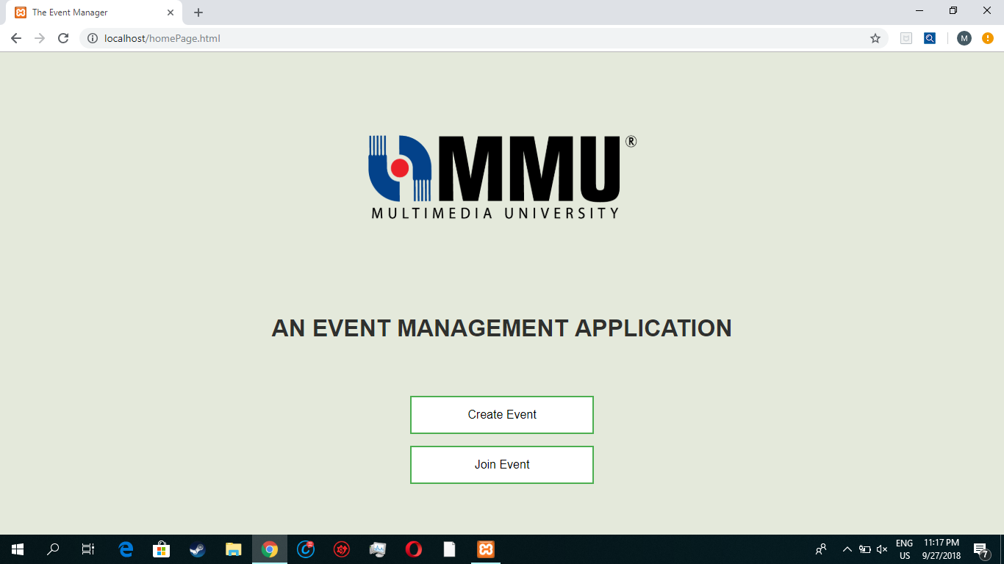

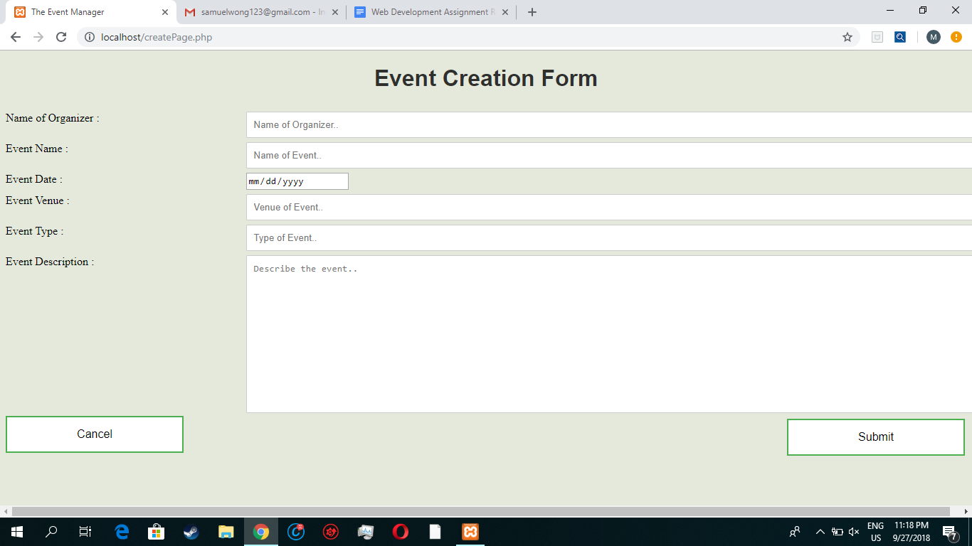

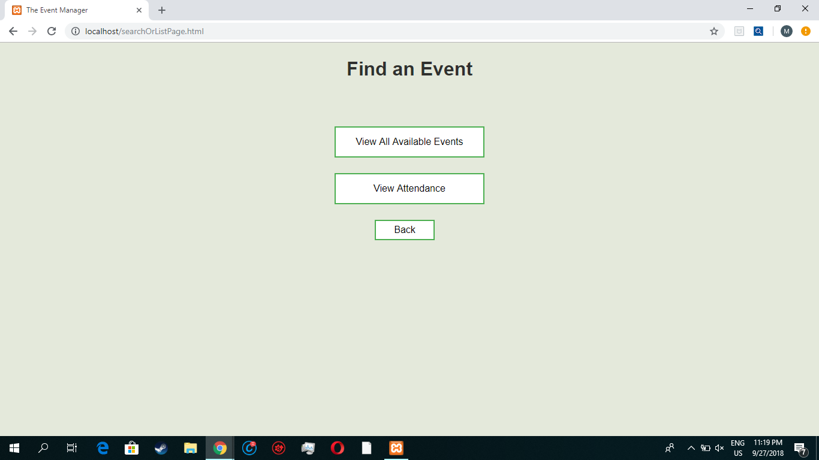

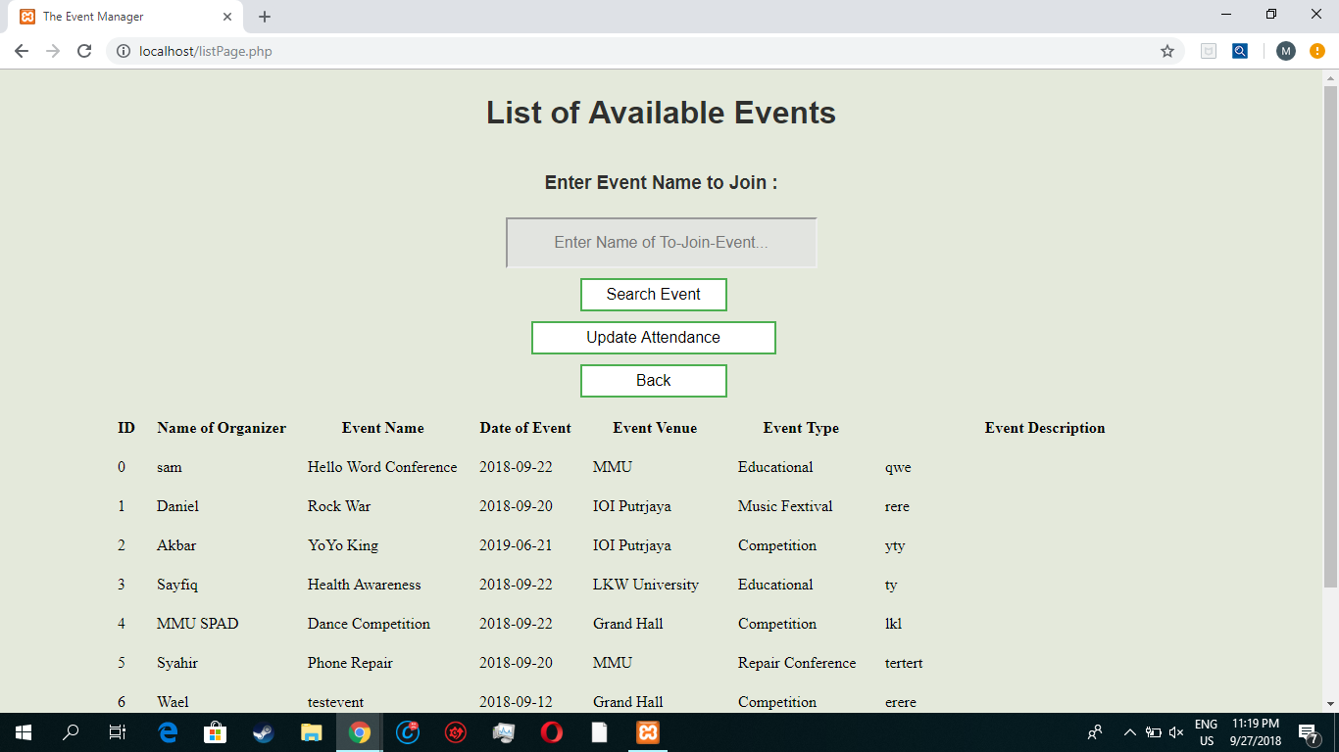

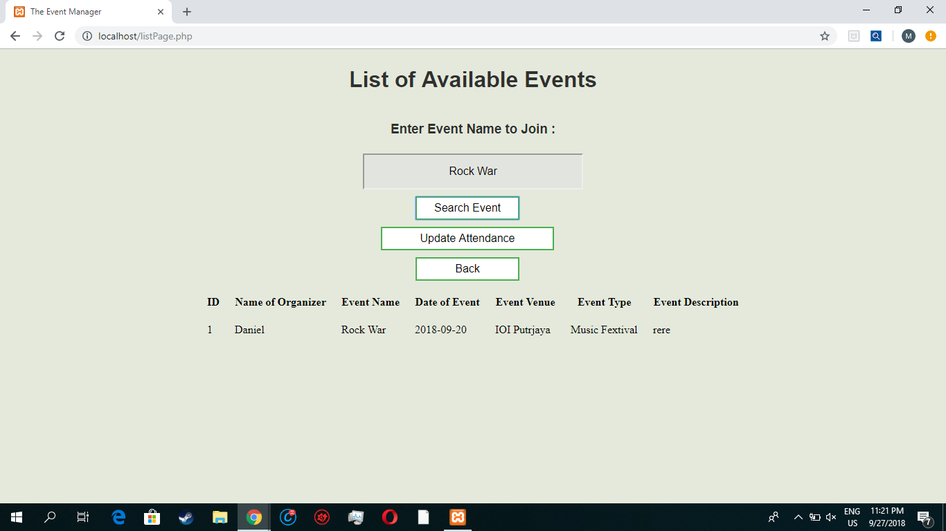

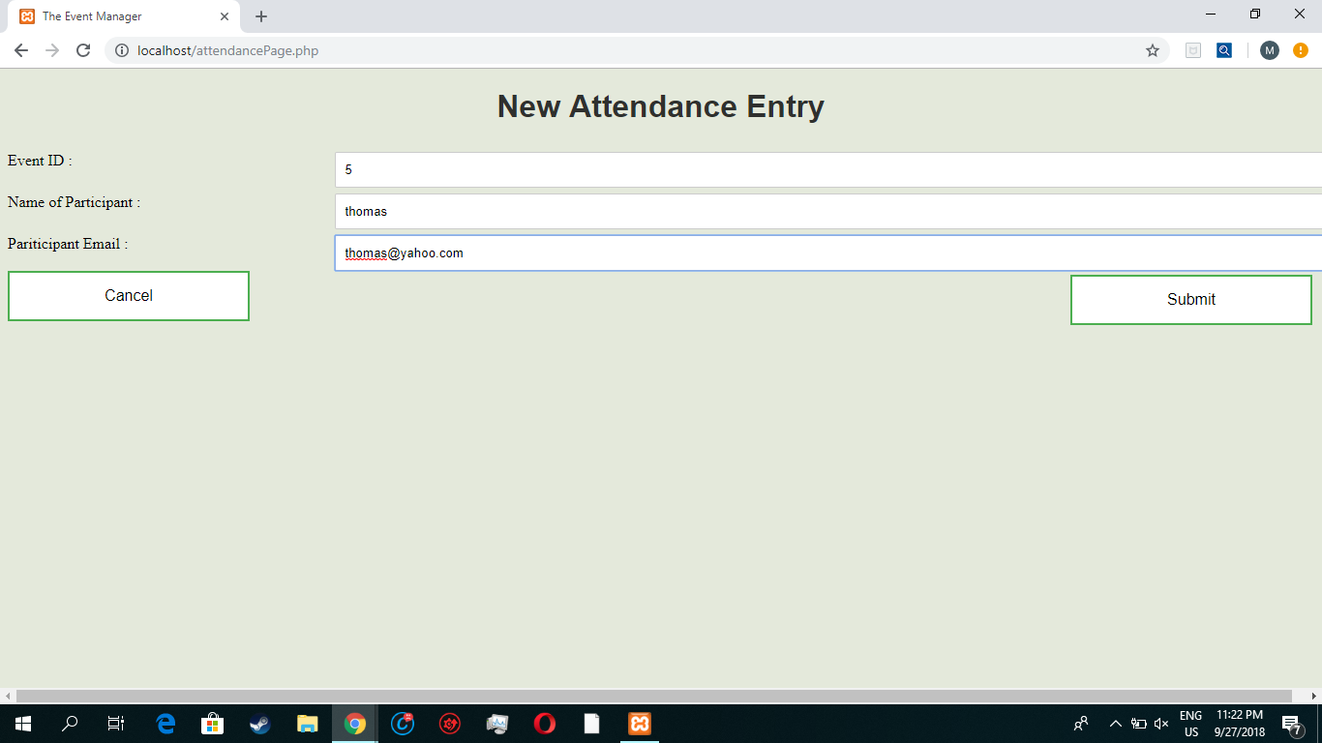

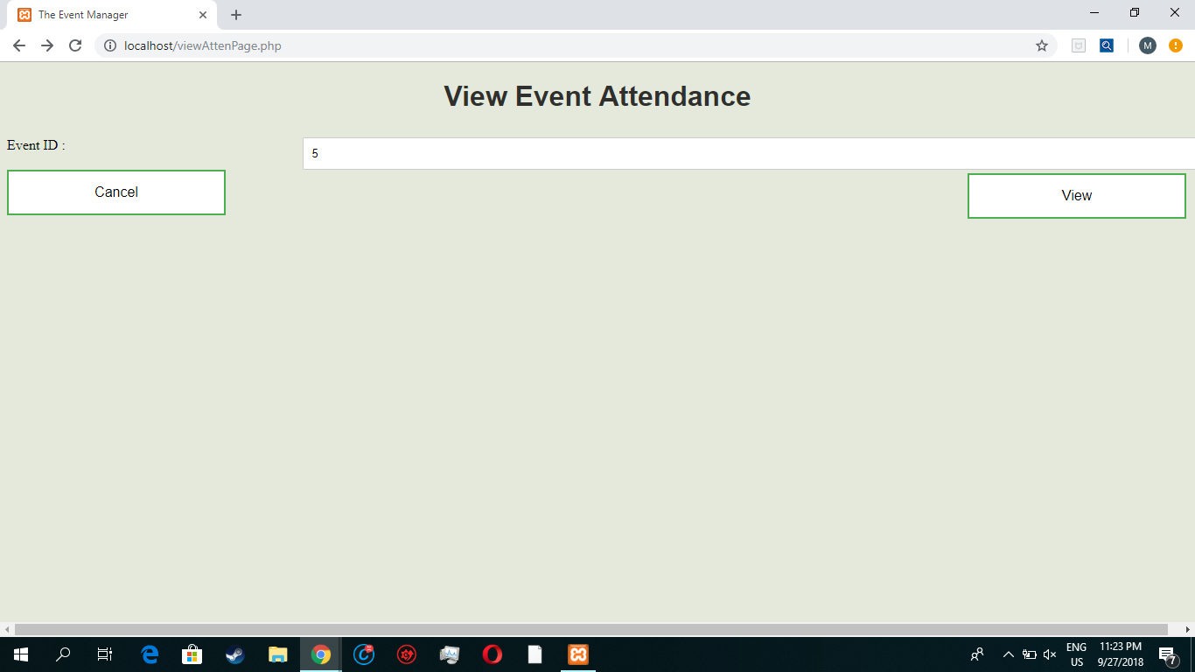

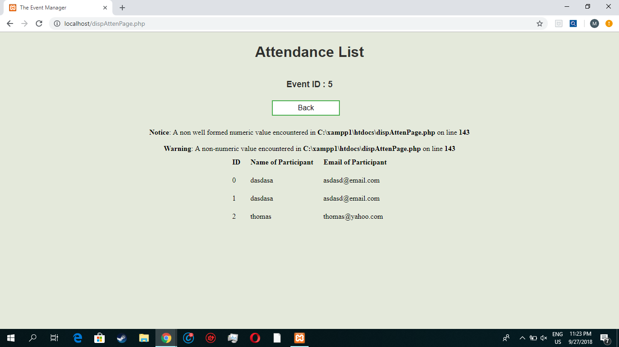

1. Functions

The following are functions that we created for the system:

1. **Create Event** 
   * Event can be created by submitting an event creation form.
   * Accessed from the welcome page.

**2. View All Available Events**

* + All events that has been created is listed in the ‘list of all available event’ page.

**3. Join Event**

* + Event can be joined by entering the event name and updating the attendance
  + Accessed from the ‘list of all available event’ page.

**4. Update Attendance**

* + New attendance entry form can be submitted to update the attendance.

1. **Search Event**
   * The search function is included in the List of available event page that list down relevant events based on the event name that is searched.
2. **View Attendance**
   * The attendance of an event can be viewed by entering the event ID and accessing its attendance list page.

**Conclusion**

By using our event management, we can use it to create/join an event such as concert, competition, health awareness etc. It also can be used to view on how many attendance that will participating with our event. We can also use it to know which event is available. Moreover, we can also add participant.

While completing this application, we have learnt useful skills including writing codes in HTML and PHP, using database to store data and basic function designing. We also learnt how to work together in a team to complete a project and also familiarize ourselves with the basic flow of system design process.

For future work, we are planning on upgrading this event management system by adding some new features like duration of the event, addition of vendor and implementing login functions. The skills that we have acquired in designing web pages using HTML and PHP can also be beneficial for simple web designs.